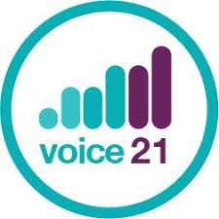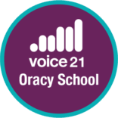

**We’re a Voice 21 Oracy School**.

We are part of a network of over a thousand Voice 21 Oracy Schools across the UK who are transforming teaching and learning through talk.

Oracy is the ability to articulate ideas, develop understanding and engage with others through spoken language. In Voice 21 Oracy Schools students learn the oracy skills they need to succeed in school and in life.

**Why oracy matters?**

By teaching pupils to become effective speakers and listeners we empower them to better understand themselves, each other and the world around them.

We actively invest teaching time into creating "talk rich" classrooms, valuing every single student voice, boosting confidence and preparing our students for their futures.

* Speaking and listening skills are critical foundations for reading and writing.
* Students with better oral language skills are more likely to achieve the highest grades in GCSE Maths and English.
* Young people with good communication skills are less likely to have mental health difficulties.

As a Voice 21 Oracy School we put oracy at the heart of our teaching and learning across all subject areas enabling students to develop and deepen their knowledge and understanding through talk in the classroom.

In Voice 21 Oracy Schools:

* 89% of students agree/strongly agree that speaking and listening has helped them make progress with their school work.
* 77% of teachers said that oracy had boosted attainment.
* 96% of teachers said that oracy is an essential part of teaching and learning.

Find out more about oracy and Voice 21 [here](https://voice21.org/)

Voice 21 additional information - if required

**About Voice 21**

Voice 21 is the UK’s oracy education charity. It works with schools to transform the learning and life chances of young people through talk so that all children can use their voice for success in school and in life. Since its launch in 2015 it has worked with over 1200 schools and 10,000 teachers across the UK, reaching more than 290,000 students through its work.

Oracy is the ability to articulate ideas, develop understanding and engage with others through spoken language. In school, oracy is a powerful tool for learning; by teaching students to become more effective speakers and listeners we empower them to find their voice for success in school and life. It underpins young people’s progress and development: their literacy and numeracy, academic attainment, wellbeing, confidence and future prospects in further or higher education and employment.