

Scholar Green Primary
& Nursery School

School Prospectus

This Prospectus has been put together by the children, staff, governors and parents of the school. We hope it helps you gain an understanding of how our school is organised and to appreciate the exciting opportunities on offer to children in our care.

WELCOME TO SCHOLAR GREEN PRIMARY SCHOOL

All schools have their own distinctive ‘feel’ which makes each one unique. We believe that the ‘special feel’ at SCHOLAR GREEN PRIMARY is to do with our caring, friendly atmosphere. Our school continues to develop in many exciting ways, providing an even more enriching experience for our pupils.

The school was last inspected by Ofsted in November 2017 when we were judged to be ‘good’ in all the key areas of the inspection including our overall effectiveness of provision. The Inspection Report said,

‘The leadership team has maintained the good quality of education in the school since the last inspection. Your energy and enthusiasm are infectious and permeate the school. You are reflective in the decisions you make and committed to providing opportunities and experiences that will enrich pupils’ learning and broaden their horizons’. | 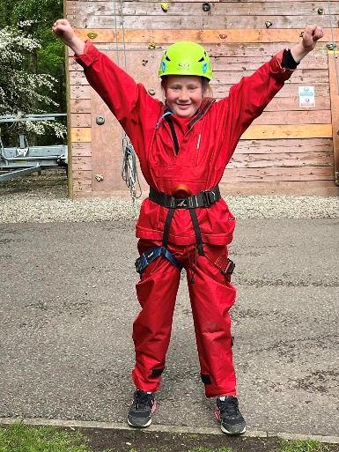
Inspectors commented,
‘You have worked hard to implement a curriculum that provides opportunities for pupils to develop and improve their knowledge, skills and understanding in writing and mathematics and in a range of other subjects, including history, geography and science. Pupils take pride in the presentation of their work and know what their next steps will be. Consequently, pupils’ outcomes are typically in line with those seen nationally and are improving. There are an increasing proportion of pupils working at greater depth’.

The best way to find out about our school is to come and visit or see us in action and meet staff and children. A telephone call to the school office on 01270 685181 is all that is needed to arrange this.

About our school

Mission Statement
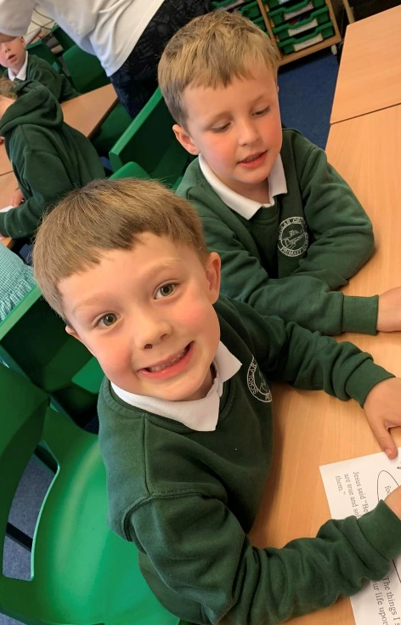
At Scholar Green Primary School we will provide every child with a safe and healthy environment in which to learn and develop the skills they need to be effective future citizens.

Aims (Outcomes)

The school aims that all children:

- are independent learners
- are confident, resilient and well-balanced
- value diversity
- understand their responsibility to others
- are self-disciplined
- are literate and numerate

Objectives (Provision)

The objectives of the school are:

- to develop a learning community
- to establish professional debate and discussion amongst all staff
- to build leadership and management skills in all staff
- to ensure that there is a learning climate in every classroom
- to create and maintain a physical environment that promotes and reinforces the value, safety and inclusion of all individuals
- to ensure the continual involvement of the whole school community

- to establish high expectations and a success culture

Vision Statement

This is our school:
- a place where every child is safe
- a place where every person is valued and respected
- a place where all efforts and achievements are celebrated
- a place where we encourage everyone to make healthy life choices
- a place where everyone is encouraged to make a positive contribution

Health & Emotional Well-Being

Alongside the teaching of knowledge, skills and vocabulary, here at Scholar Green Primary School, we aim to promote positive mental health for every member of our school community including, staff, pupils and families. We pursue this aim using both universal and whole school approaches as well as specialised, targeted approaches aimed at vulnerable pupils. A bespoke emotional health, well-being and resilience programme is embedded in our curriculum alongside the teaching of knowledge, skills and understanding in all other curriculum subjects. We have a dedicated member of staff in school full time that deals with the emotional well-being of all our school community. Pupils are encouraged to talk openly about their mental well-being and access support as and when required. We aim to provide pupils will the tools and strategies needed to cope when faced with challenges within school or home life.

Parents in partnership

We welcome parents and carers into Scholar Green Primary School believing we are partners in the education of your children.

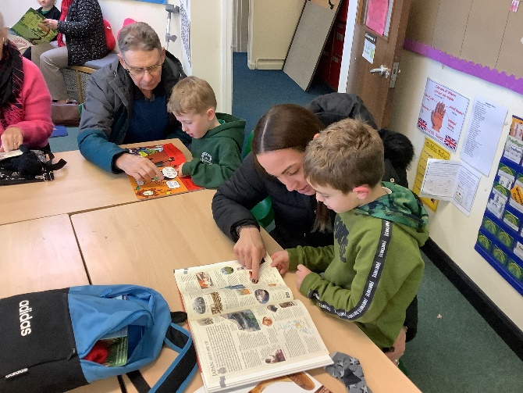
There are many opportunities for
parents to become
involved in the life of the school
and to gain a greater
understanding of its work.
Parent’s support and
expertise can be used in many
ways and is greatly valued. Police checks
and DBS checks are carried
out on all adults working in school
including regular volunteers

Communication with parents

We communicate with parents and carers in various ways, for example through our termly newsletters, questionnaires, workshops and informal social events. Parents are regularly invited to assemblies, and to Parents’ Evenings each term. Every year parents and others are invited to attend our Sports Day as well as children’s performances.

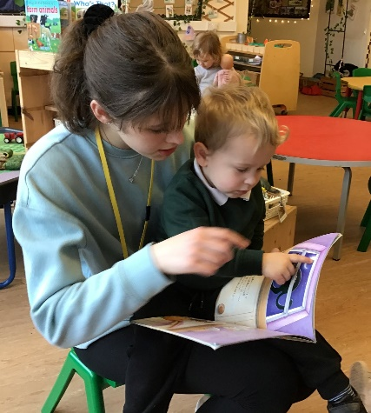
Staff will always be happy to meet with parents and carers to share any concerns.
The school has a Home School Agreement to support the partnership between home and school, and foster shared dialogue. Parents and others are involved in policy development through consultation and working parties.

The School’s website has a wealth of information including our half-termly phase newsletters, class pages and copies of key policies.

PARENT TEACHER ASSOCIATION

The PTA exists to support the life and work of the School and is open to all members of the school community. The Association provides invaluable support to the school through organising many social and fundraising events involving parents and the wider local community. Money raised provides extra facilities and equipment for the pupils. The group holds regular meetings in school. The PTA identifies long and short-term projects for its fundraising; which enables us to buy ‘special’ extras to enhance pupils’ school experience. The PTA needs the support of parents to ensure it is able to continue to enrich the lives of children. As a new member of our school community we hope you will be able to add your support to the work of the Association.
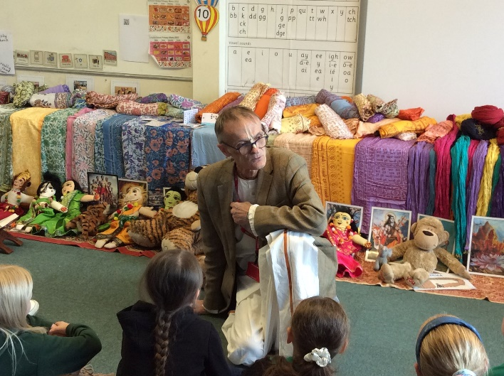
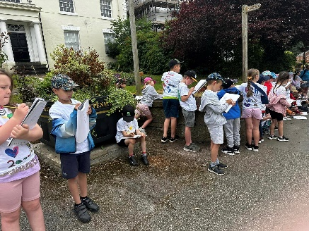
JOINING THE SCHOOL

ADMISSION ARRANGEMENTS

Administration of admission arrangements to County Primary
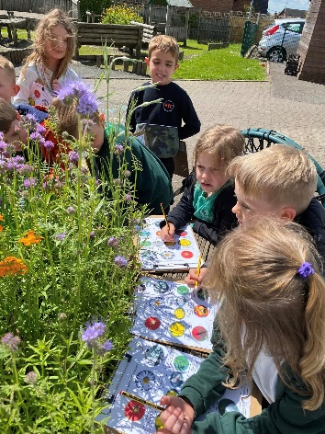
Schools is dealt with centrally by Cheshire East Council. A booklet,
‘Starting School’ setting out the Reception admissions procedures
and criteria for each school, together with an application
(Common Admission Preference Form) is available from the
County Council Admissions Team. Completed forms, or online
admissions, must be returned to the School Admission Team
or first preference school by the submission date in the
Autumn Term prior to starting.

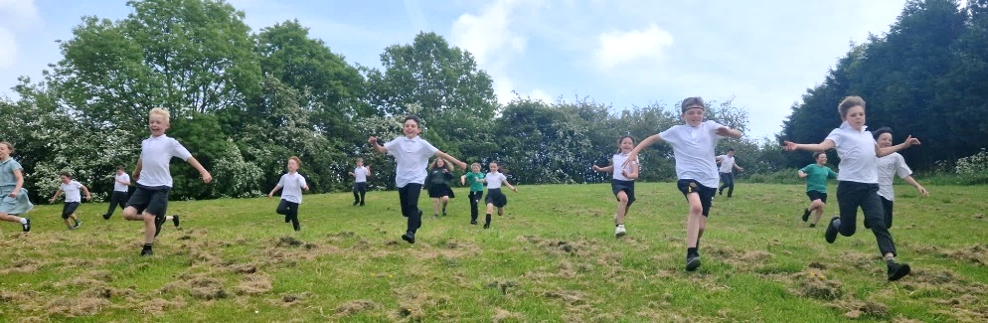
Parents and carers of children seeking to join the school in other years, should in the first instance contact the In-year Admissions Team of the County Council on 0300 1235012

Scholar Green Primary School welcomes all children regardless of special needs or disability. Pupils with additional needs may have extra visits before starting school and there will be close liaison with parents to ensure that the correct arrangements are in place.

APPEALS

Every effort is made to make a place available for your child in our school. However, schools have a limit on the number of children they can take. In the case of Scholar Green Primary School this is 30. This figure is set by the Local Authority (LA) and agreed with Governors and Headteacher. If the number of children wanting a place is below the set figure, your child will be offered a place. There may, however, come a point when there are too many children of that year group for them all to be given a place. If a place is not available on application, you have the right to appeal to Cheshire East Council. Appeals are heard by an independent panel. A Guide to Admission Appeals can be obtained from the Admissions Team.
STARTING SCHOOL FOR THE FIRST TIME

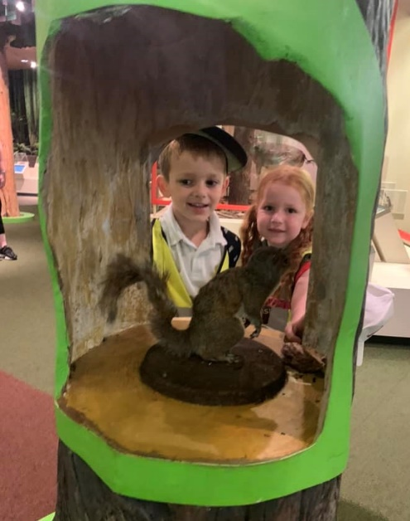
Starting school is a very important time for you, your child and the school. We all need to work together to make the transition smooth and rewarding.
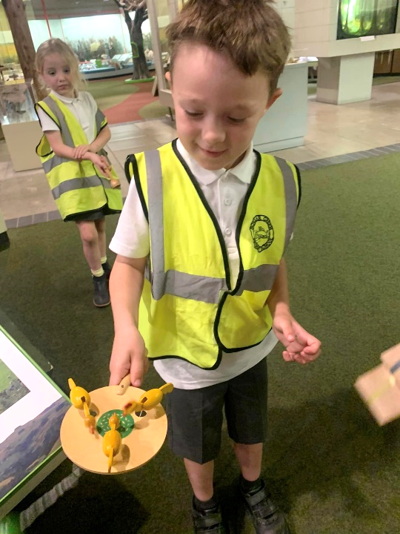
In the term prior to their entry, pupils are invited into school for visits. This will help them become familiar with the surroundings and routines of school. During this period, there will be meetings for parents to discuss our partnership with you and talk about any concerns you might have. Pupils will be admitted to Scholar Green Primary School in the September of the academic year in which they are five. The Early Years Curriculum is grounded in active learning. Through practical activities, purposeful play and talk, pupils develop an understanding of the world and the basic concepts they will need for their later learning. Parents can play a major role in fostering good attitudes to learning, developing language skills and promoting good behaviour.

Every child deserves the best possible start in life and the support that enables them to fulfil their potential. Children develop quickly in the early years and a child’s experiences between birth and age five have a major impact on their future life chances. A secure, safe and happy childhood is important in its own right. Good parenting and high quality early learning together provide the foundation children need to make the most of their abilities and talents as they grow up.

The Early Years Foundation Stage (EYFS) sets the standards
that all Early Years’ providers must meet to ensure that
children learn and develop well and are kept healthy and
safe. It promotes teaching and learning to ensure children’s
‘school readiness’ and gives children the broad range of
knowledge and skills that provide the right foundation for
good future progress through school and life.
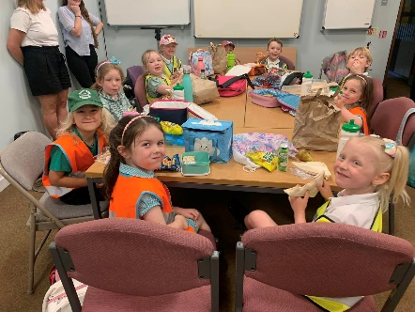
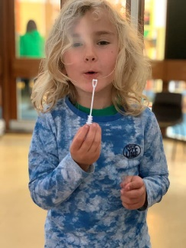

At Scholar Green Primary School we value the potential of home-school links and make every effort to involve parents in the learning and development of their child. At the start of each new school year, class teachers run workshops about the curriculum and how parents can help their child at home.

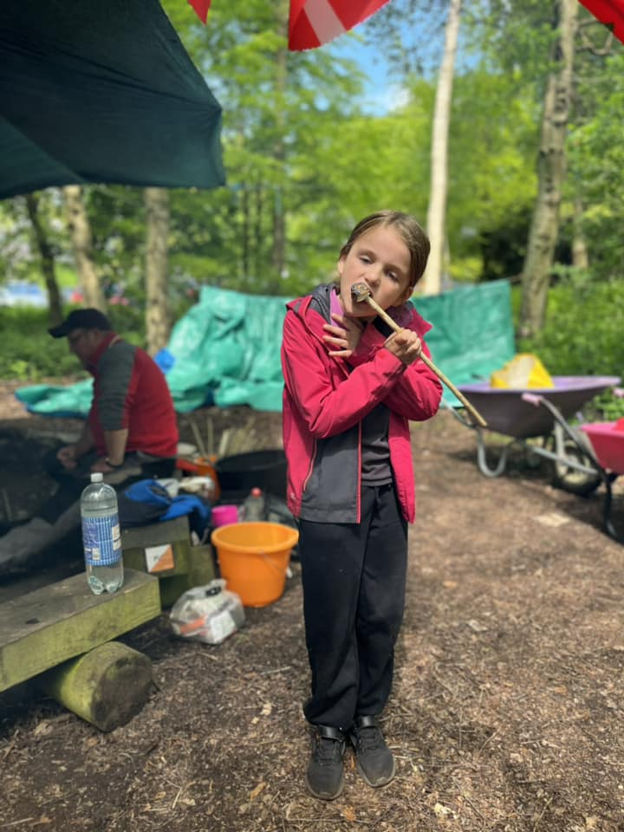
JOINING THE SCHOOL LATER ON

Sometimes children join the school later on in their school
life. We make every effort to ensure they are welcomed,
looked after and monitored so that they quickly make
friends and can find their way around the school.
Teachers give children time to settle in before
making an assessment of their academic abilities.
This assessment, together with records from the
previous school, will enable your child to have the
best start in our school. Parents and carers are asked
to contact the school if their child has difficulty settling.

THE CURRICULUM
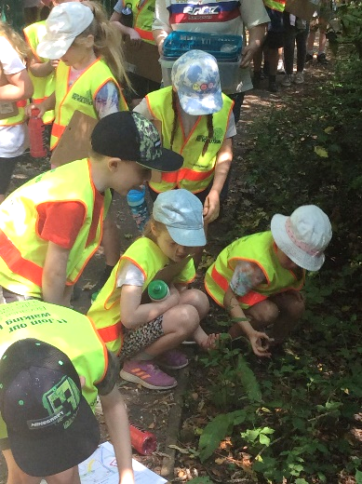
The School curriculum comprises all learning and other experiences that we plan for our pupils. The central aims of our curriculum are to work in collaboration with families and the local community to provide opportunities for all pupils to learn and to achieve; to promote pupils’ spiritual, moral, social and cultural development and prepare all pupils for the opportunities, responsibilities and experiences of life. The curriculum of the school is organised so that children are stimulated, encouraged and challenged to develop their individual potential and personality to the full.

At Scholar Green Primary our curriculum combines academic and enrichment experiences, that we plan, to meet the needs and interest of our pupils. It is constantly evolving to develop the skills required for children to become successful learners, help prepare them for life in modern Britain and empower them to achieve success in the future. Our aim, to deliver a dynamic and innovative curriculum that challenges, excites and inspires children to become successful and confident learners and achieve their best, is the main driving force behind how we design and deliver our curriculum.

The school’s curriculum promotes and sustains
a thirst for knowledge and understanding, and
a love of learning. It covers a wide range of
subjects and provides opportunities for
academic, technical, creative and sporting
excellence. It has a very positive impact on
all pupils’ behaviour and safety and contributes
very well to pupils’ academic achievement, their physical well-being and their spiritual, moral, social and cultural development.

Our curriculum is planned in themes, with topics chosen to capture the interests and imaginations of our children.

In addition to our exciting and stimulating themes, we also provide further opportunities to enhance children’s learning wherever possible.
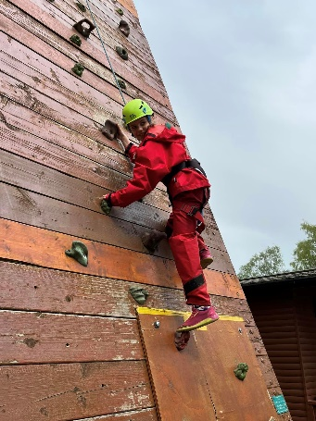



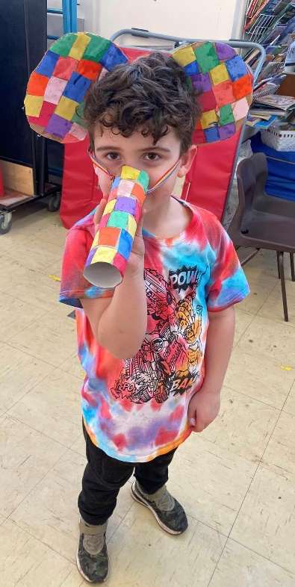
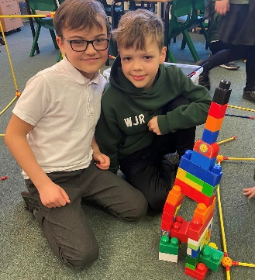
WHOLE SCHOOL THEMED DAYS/WEEKS
Throughout the year, themed days/weeks
are woven into the curriculum to extend
the breadth and balance of opportunities
we offer our pupils. These include –
Anti-bullying Week and Internet Safety Day,
Creative Arts Week, World Book Day,
National School Sport & Health Week,
Enterprise Week, Fair Trade Fortnight,
Science Day, Cultural Day, Community Day &
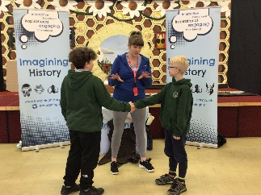
European Day of Languages.

EDUCATIONAL VISITS

School trips and visits are an integral part of the education of children at Scholar Green Primary. We value the opportunities such visits offer our pupils and the commitment of staff and adults undertaking them. Trips include: class visits, aimed at bringing learning alive and providing first-hand experience; extra-curricular outings, such as activities with the school choir or sporting events and attending or taking part in performances or competitions.
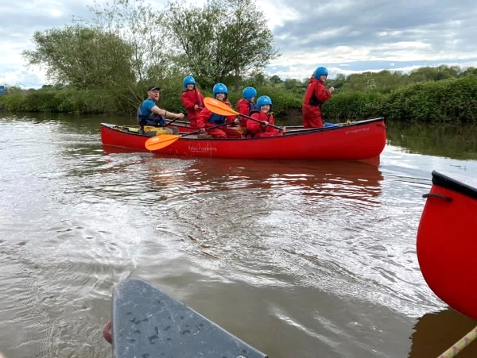

Children in Years 2, 3, 4, 5 and 6 have
the opportunity to take part in residential
visits in the North West. There is also a
European Residential for pupils in
Years 4, 5 & 6 to Paris. This enhances
our Modern Foreign Languages curriculum.

VISITORS INTO SCHOOL

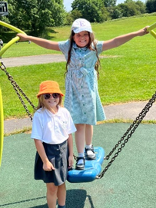
Visitors have a valuable role to play and can contribute to many aspects of the life and work of the school. They deliver talks, workshops and full day activities across a wide range of subjects, giving pupils access to outside experiences and expertise. Visitors provide a link with the wider community – children have the opportunity to work alongside artists, musicians, authors, health professions and others.
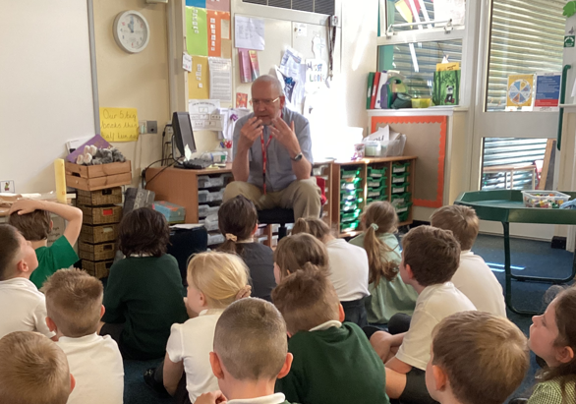

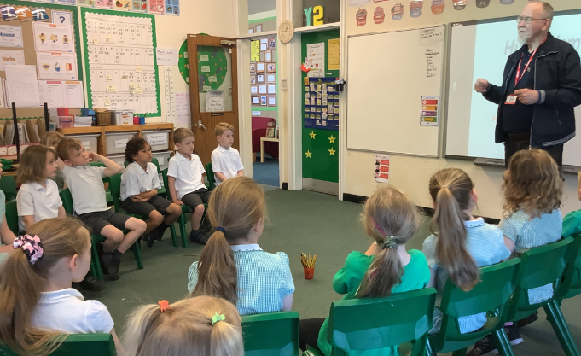

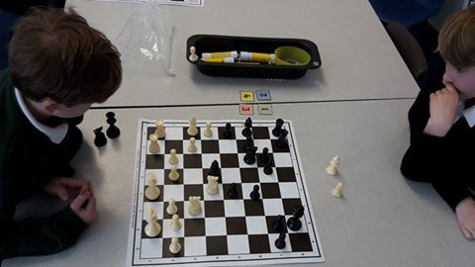
EXTRA CURRICULAR CLUBS
As a school we offer pupils opportunities to participate in extra-curricular activities after school. At any time a wide range of clubs is on offer – our programmes of clubs and activities available is revised termly depending on the time of year and other commitments children may have. Recent Clubs includes football, basketball, rugby, gymnastics, art & craft, science – space club, drama, chess, choir, computing and construction.

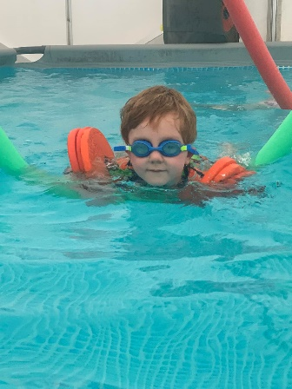
PE & SPORT

We employ sports coaches to provide high quality instruction during PE lessons and after school. We also use local facilities to support us with our provision. This includes the local swimming pool, local high schools and outdoor adventurous centres. We are delighted to have been awarded the Gold Award for sports provision.

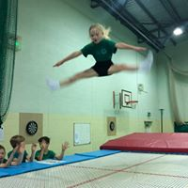
During curriculum lessons, pupils participate in activities such as football, basketball, tennis, golf, cricket, hockey, netball, dodgeball, trampolining, climbing, swimming, dance, rounders, athletics.
Pupils also have the opportunity to compete against other local schools in a variety of different team sports.
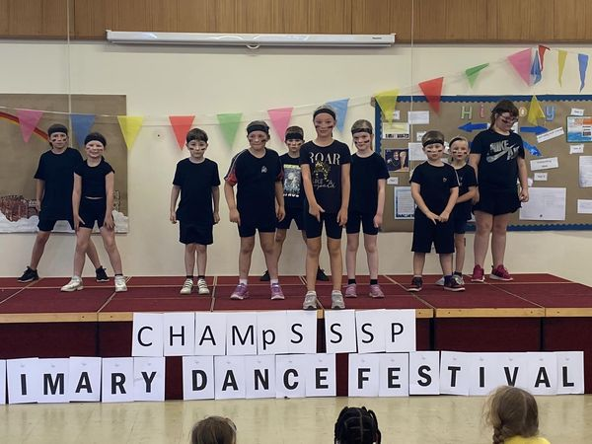





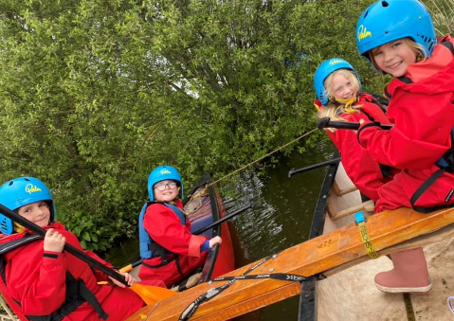

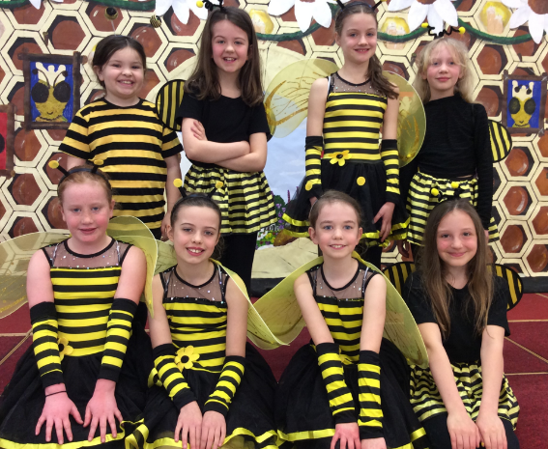
MUSIC, ART & DRAMA
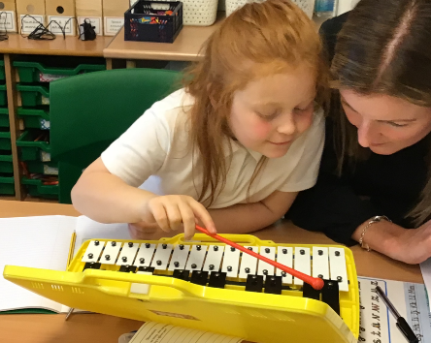
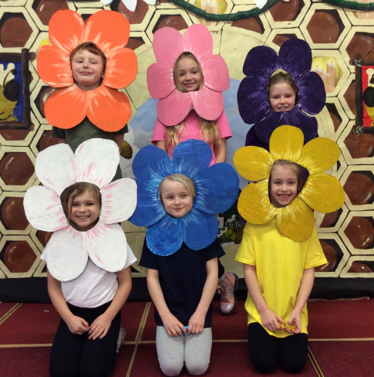
We provide opportunities for children to take part in a wide range of musical activities and performances where they are encouraged to sing, compose and work creatively with sound. Through active listening, pupils’ awareness, understanding and appreciation of a wide variety of music are developed. A range of opportunities are provided within and beyond the curriculum for children to showcase their musical skills and talents. Pupils are able to learn an instrument within school and then gain a recognised qualification at the end of Year 6.



EQUALITY
At Scholar Green Primary School, we are committed to ensuring equality of education and opportunity for all pupils, staff, parents and carers receiving services from the school, irrespective of race, gender, disability, faith or religion or socio-economic background. We aim to develop a culture of inclusion and diversity in which all those connected to the school feel proud of their identity and able to participate fully in school life.

The school recognises it has to make special
efforts to ensure that all groups prosper including:
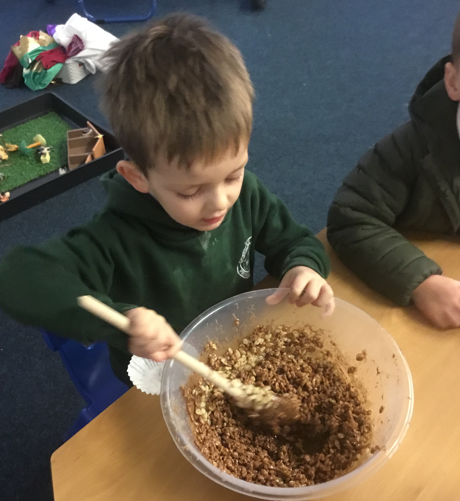
• Boys and girls, men and women
• All minority ethnic groups including travellers,
refugees and asylum seekers
• Pupils or families with different religions or beliefs
• Pupils and others with special educational needs
• Pupils and others with a range of disabilities
• Children who are looked after and their carers
• Children or staff who are gay or lesbian
• Pupils or staff undergoing gender reassignment

Theachievement of pupils is monitored by race, gender and disability and we use this data to support pupils, raise standards and ensure inclusive teaching.
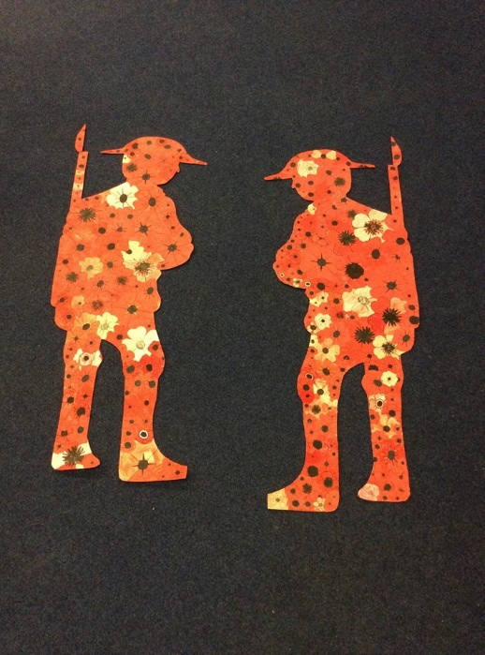
We tackle discrimination by the positive promotion of equality, challenging bullying and stereotypes and creating an environment which champions respect for all. As a school we believe that diversity is a strength, which should be respected and celebrated by all those who learn, teach and visit us.

As a school we try to ensure that disabled pupils can play as full a part as possible in school life. We implement accessibility plans, which are aimed at:
• Increasing the extent to which disabled pupils can participate in the curriculum.
• Improving the physical environment of schools to enable disabled pupils to take better advantage of education, benefits, facilities and services provided.
• Improving the availability of accessible information to disabled pupils.

SAFEGUARDING

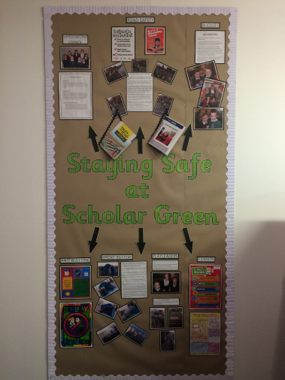
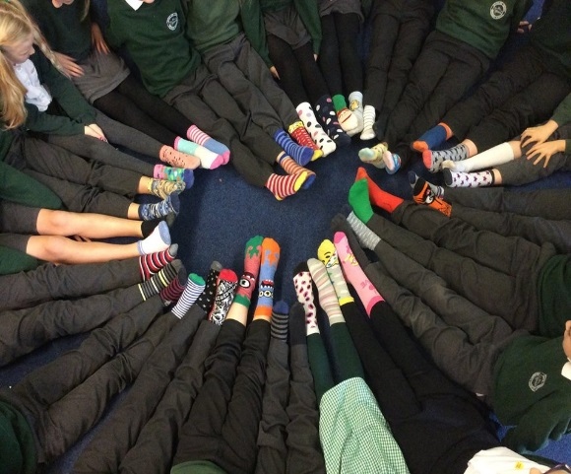
Scholar Green Primary School is committed to safeguarding and promoting the welfare of children and expects all staff and volunteers to share in this commitment. Staff work hard to maintain an environment where children feel safe and secure. The curriculum is designed to ensure opportunities for children to develop the skills they need to recognise and stay safe from abuse. Children know that they can approach any of the adults in school if they are worried and that they will receive a consistent supportive response. In recognising our responsibilities for Safeguarding and Child Protection, as a school we: • Have clear staff recruitment and selection procedures, ensuring that all staff (including volunteers) who have unsupervised access to children, have been appropriately checked for their suitability through the DBS procedure.
• Aim to raise awareness of child protection issues and equip children with the skills needed to keep them safe.
• Develop and implement procedures for identifying and reporting cases, or suspected cases, of abuse.
• Support children who have been abused in accordance with his/her Child Protection Plan.
• Establish a safe and nurturing environment free from discrimination or bullying where children can learn and develop happily.
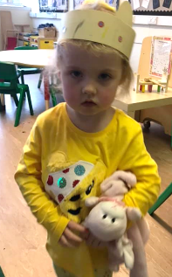

We have a Safeguarding Policy which explains how the school works to ensure that children are thriving and safe. We take safeguarding and the protection of children very seriously. If we have any concerns about a child’s welfare it is the Headteacher’s responsibility to contact Social Services. If you have any concerns about the well-being of a child please inform us in confidence immediately.

If you would like to know more about our policy or procedures for Safeguarding, please speak to Lyndsey Colman, Headteacher, who is our designated lead for Child Protection.

BEHAVIOUR

At Scholar Green Primary School we believe that children learn best in a well-organised, calm and secure environment where purposeful and self-disciplined behaviour is expected. We want every child in our school to feel confident, happy and safe. As a caring school we have the highest of expectations in terms of learning, behaviour and attitudes, and encourage our children to develop similar beliefs in their own potential, together with pride in their achievement.
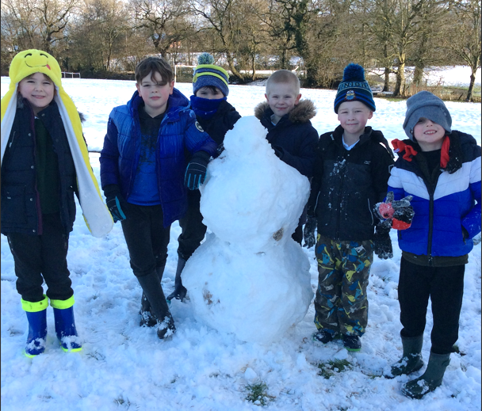
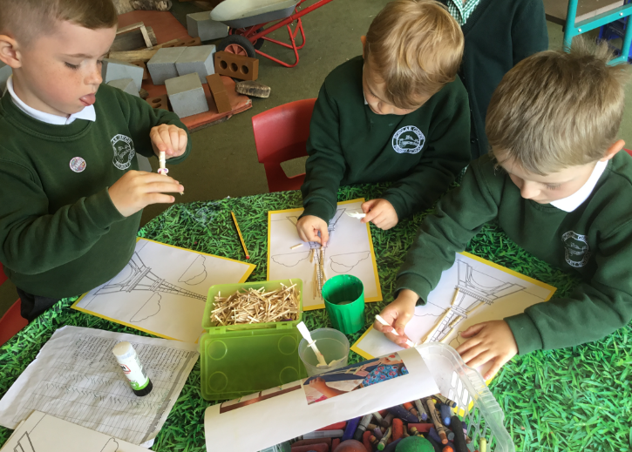

The aims of the school, and the rules of behaviour consistently promoted in each classroom, are ones that emphasise positive behaviour and collaboration in striving for excellence. Whole-school systems emphasising praise, recognition and reward exist to promote and celebrate sustained effort and hard work, and contributions towards the school community.

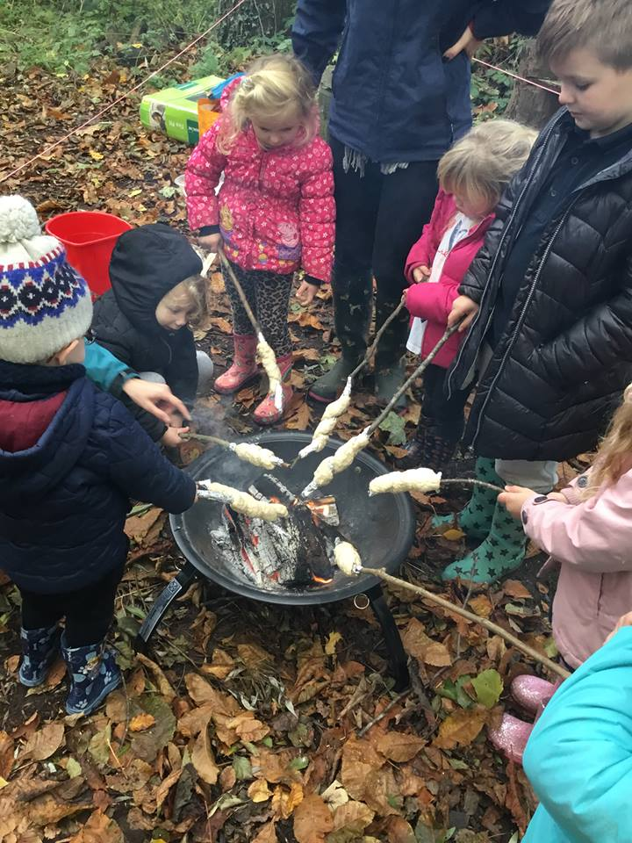
All forms of bullying and harassment are considered to be unacceptable and are not tolerated within the school environment. All incidents will be taken very seriously and followed up in accordance with our Anti-bullying Policy which is available via the school’s website.

The school’s abhorrence of such behaviours is communicated to pupils, parents and staff, for example through the curriculum, the Prospectus and staff training. All parents of new pupils receive a summary of the school’s behaviour expectations and Anti-bullying Policy as part of an Induction Pack.

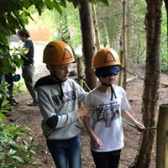
All staff are expected to deal with any discriminatory incident that may occur. They are expected to know how to identify and challenge prejudice and stereotyping; and to support the full range of diverse needs according to a pupil’s individual circumstances. As a school we believe bullying is best prevented through an ethos based on mutual respect and equality. The raising of children’s self-esteem and self-confidence is central to the work and life of the school.

We recognise that in the school environment bullying can have a devastating effect on learning and the emotional health and well-being of pupils. Challenging bullying effectively will improve the safety and happiness of pupils, show that the school cares and make clear to bullies that such behaviour is unacceptable. In addition, these benefits translate into improved life outcomes for pupils, a more satisfying working life for staff, and a more successful and inclusive school community.
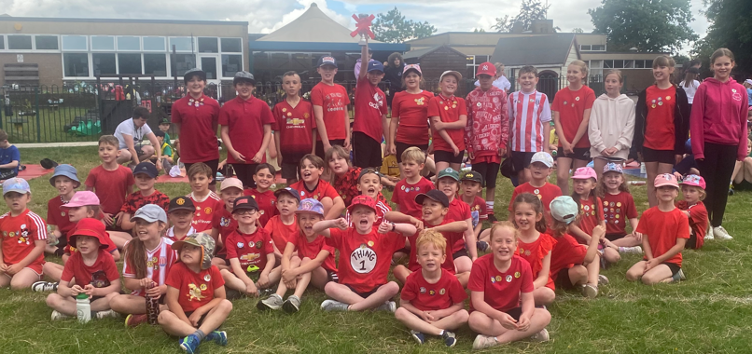

Other Information

SCHOOL MEALS
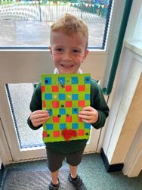
All pupils in Reception, Year 1 and Year 2 are offered a free school. Schools are legally required to provide meals that comply with the School Food Standards. These standards are intended to ensure that children get the nutrition they need across the whole school day and govern all food and drink on offer within the school. We work with our meals provider, in liaison with parents, to cater for any pupils with special dietary needs. Menus are supplied to parents in advance so that meals can be pre-ordered; parents can choose not to take-up a school lunch for their child, in which case children should bring a healthy packed lunch into school.
If you think your child is eligible for free school meals, please collect a form from the school office or apply online https://www.cheshireeast.gov.uk/schools/free_school_meals.aspx.

LOST PROPERTY
Naming all items reduces the risk! Any items of lost property are put in a central ‘Lost Property Box’ in the main entrance - if your child has lost something then please check there. We do keep lost property for a reasonable period of time but it is often difficult to identify items that are not named. Displays of lost property are made at the end of each term.

ABSENCE
If your child is unable to attend school for any reason please telephone or e-mail the school office, before 9am, to let us know. If your child has sickness or diarrhoea we ask that he/she does not return to school for 48 hours as this type of illness can be very infectious.


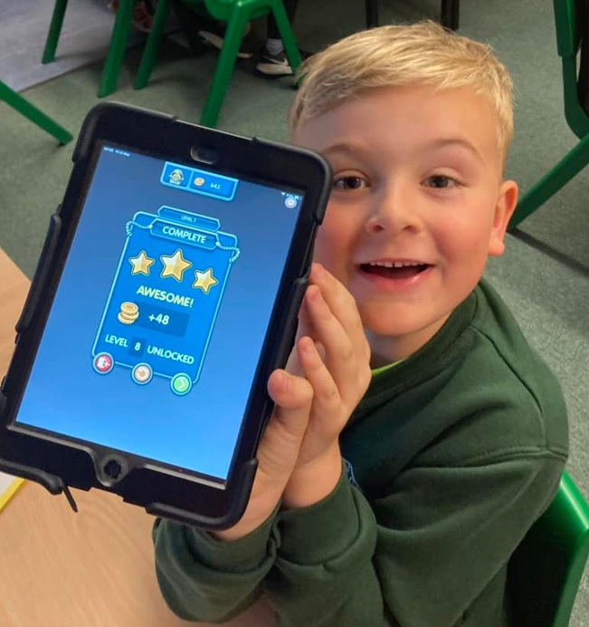
To encourage high levels of attendance, certificates are awarded to children at the end of the Autumn, Spring and Summer for 100% attendance; for 100% over the school year.

PUNCTUALITY
The school day begins promptly at 8:50am and we ask that children arrive promptly to ensure a positive start to their learning. Please ensure your child is not late for school. Children who arrive late are asked to report to the school office on arrival. Any late attendance is recorded on the end of year school report to parents.

HOLIDAYS DURING TERM TIME
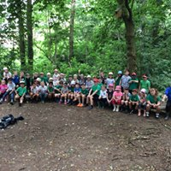
From 1 September 2013 new DfE regulations have come into force regarding leave of absence for children from school. The current law does not give any entitlement to parents to take their child on holiday during term time. Any application for leave must be in exceptional circumstances and the Headteacher must be satisfied that the circumstances warrant the granting of leave. The School’s Attendance Policy is available to download on our website.

TIMES OF THE SCHOOL DAY
Children should not arrive unaccompanied before 8:50 am when the school doors are unlocked. Football and other games are not allowed before school because of younger children and adults’ presence on the playground at this time. All children should be in their classroom by 8:50 am at the latest for a prompt start to the school day. The school gates are locked at 9.00 am and reopened at 2:50 pm.
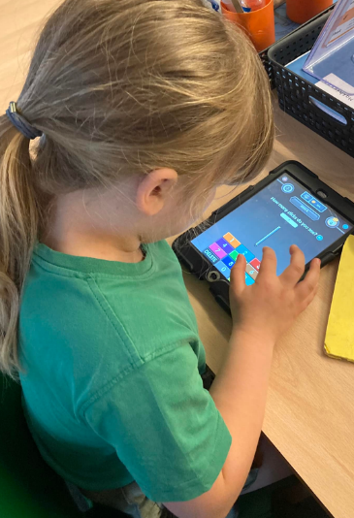
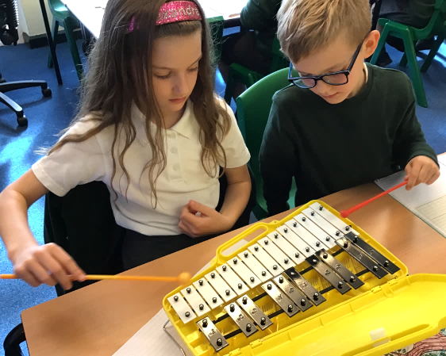
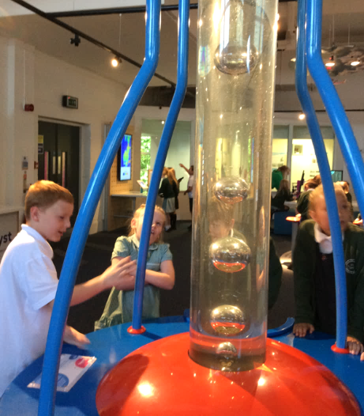

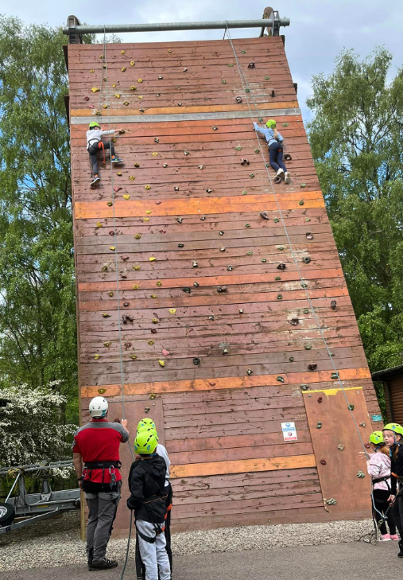
MEDICAL & OTHER NEEDS
When children start school, parents are asked to
complete a form outlining any medical history,
including any allergies suffered, that we should
be aware of. It is important that this record,
including contact details, is kept up-to-date.

FIRST AID
Basic first aid is given at school when necessary
by qualified First Aiders. If an accident needs
hospital attention we will make every effort to
contact parents. We ask parents to ensure all
contact details are kept up-to-date so that we
can contact you in an emergency.
All injuries are recorded.

MEDICINES
The school has responsibility for the safety and welfare of pupils and regularly reviews arrangements to ensure that the medical needs of the pupils are met at school.
There may be times when children attending school need to take medication. Any such medicines needed by a child during the school day should be brought to school in the smallest practicable amount by the parent/carer, not the pupil, and be delivered personally to the Administrative Officer or Headteacher. These medicines must be in the original bottle/ packaging in which prescribed, clearly labelled with the:
• Pupil’s name
• Contents
• Dosage
• Date
Parents will be asked to complete a written request for the school to administer medication. Medicines in school are kept in a locked cupboard or in a refrigerator away from the pupils. A record is kept of all medicines administered.
Asthma inhalers are prescribed medication and parents are asked to complete a Parent Request Form on their child’s entry into school.

As children may need immediate access to their inhaler (Blue Relievers), they are kept in a safe and readily accessible place. Inhalers should be taken to sporting events and used prior to or during exercise if an episode of asthma occurs.
Parents are encouraged to provide the school with full information about their child’s medical needs so that staff can exercise appropriate levels of care.

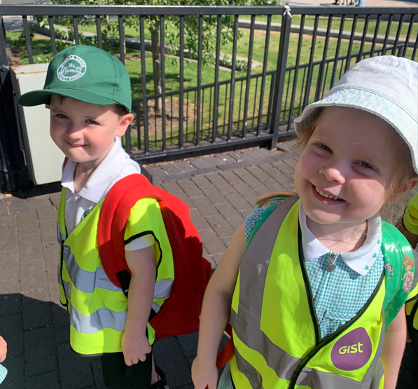
SUN PROTECTION
During warm summer months all children
should have a named sun hat in school
which they will be encouraged to wear
when playing outside. School staff are not
permitted to apply sun cream to children.
We would ask that you apply a long-lasting
sunscreen before school in sunny weather.
Children may reapply their own sun cream
which must be provided in a clearly named
container.

SMOKING
We operate a no-smoking policy - smoking is not permitted anywhere within the school or grounds.

MONEY
Please ensure that all monies sent to school are in a sealed envelope marked with your child’s name, amount and the purpose of the money.

COMPLAINTS
Any complaints about school matters should first be discussed with class teachers then brought to the attention of the Headteacher if you feel it has not been successfully resolved. If the complaint is still not resolved, a formal complaint may be made firstly to the Governing Body and secondly to the Local Authority. The procedure to register a complaint is available from the school’s Administrator.
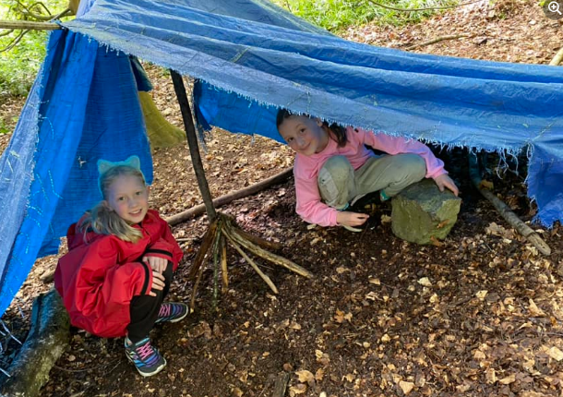
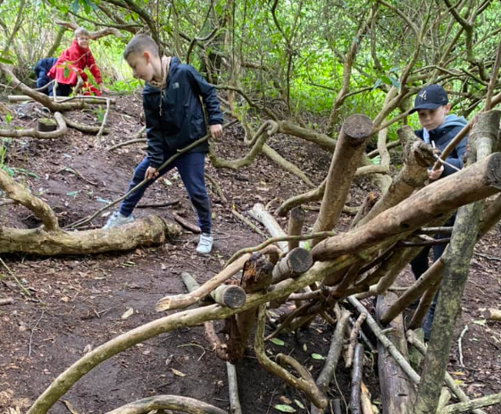

CHARGING POLICY
At Scholar Green Primary we are constantly seeking to enrich the children’s learning experiences through trips, by inviting visitors and experts to talk to the children and by running activities and workshops. The children always feedback that these activities bring learning to life and are some of their most memorable experiences of primary school. Where possible, teachers look for free activities or apply for grants that will enable the school to provide enrichment opportunities at no cost to families.


CONTACTS

Address Scholar Green Primary School
Congleton Rd North
Scholar Green
ST7 3HF
Telephone 01270685181
Website www.scholargreen.cheshire.sch.uk
Headteacher Lyndsey Colman

Chair of Governors Pat Morgan

OTHER INFORMATION

Type & Age Range Nursery & Primary School
2 - 11 Years

Number on School Roll Full time 185
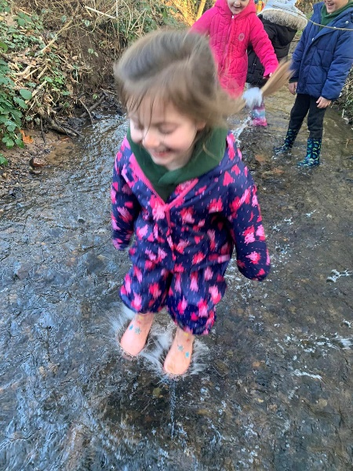
SCHOOL HOURS

Morning 08.50 - 12.00 (12.15pm KS2)
Afternoon 13.00 - 15.15pm

WRAP AROUND & HOLIDAY CLUB CARE HOURS
– “The Den”

Morning - 07:30-09:00am
Afternoon – 3:15-6:00pm

