Yellow Day 2022
Children’s Mental Health Awareness Day
Year 4
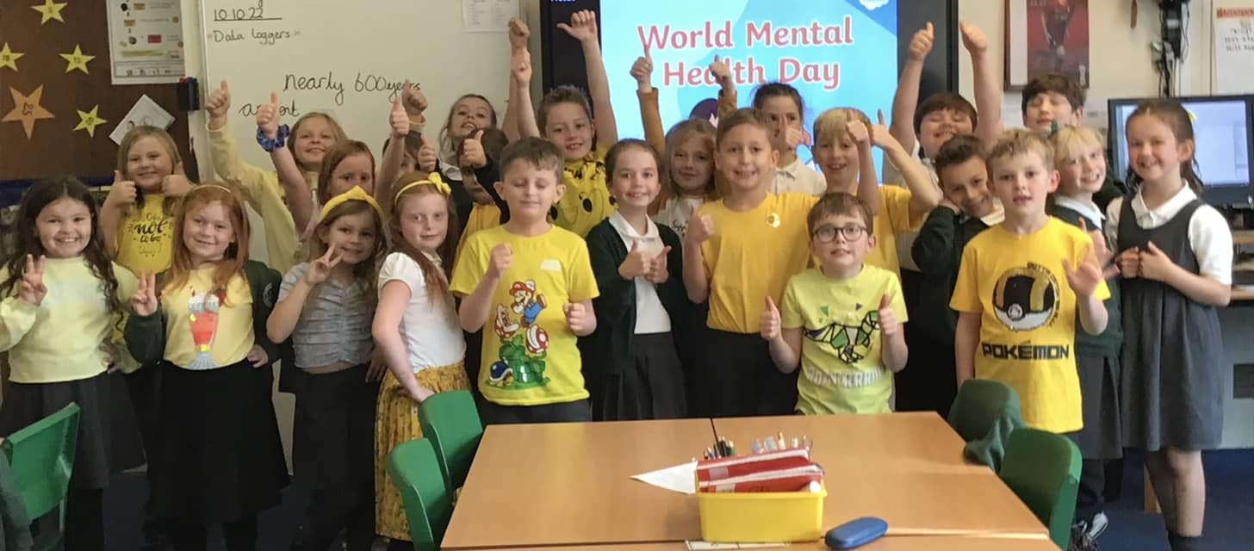
Year 1
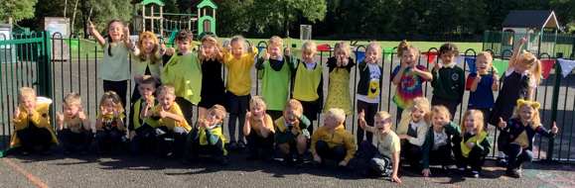
Reception
