EYFS Spring 1 Newsletter
Happy New Year!
We trust you have had a good holiday and are ready to embark on the New Year. We have got a busy half term planned, so here is an over of what we have planned so far. The EYFS curriculum is child centred and our learning is planned from their interests so it difficult to give a breakdown of exactly what we will be covering, therefore I shall give you an overview on the parent notice board in our classroom window and update the blog as often as possible.
Topic
Our Topic this half term is based around Transport. We will be thinking about being safe near to roads and the green cross code. We will be looking at different types of transport over the weeks and the children will share which types they have been on before. There will be lots of investigations into floating and sinking, how things work and which car moves the furthest. At the end of this half term we will also look at how Chinese New Year is celebrated and a visitor will be coming into to talk to us.
Literacy
We will be reading lots of stories based on the theme of transport and journeys. Noah’s ark will feature and link largely to our music and movement experience. We will also be reading a story about ‘The Naughty Bus’. We are going to focus on the retelling of stories and order of events. Writing will feature more this half term too. We will learn how to ask questions that are relevant to a topic to and look for answers in non-fiction books.
Maths
We will continue with the highly successful Maths Makes Sense programme. We are going to focus on number formations, addition and subtraction using the cups to help us.
Phonics
We are continuing with the Read, Write, Inc programme. The children will continue to be introduced to new sounds throughout the weeks. The development of letter formation will be key element here too.
Homework
There will be a new homework sheet stuck into book in the second week. Homework will continue to be handed out on a Thursday and due back in on the following Tuesday. Please make every effort to complete some homework with you children, as well as reading regularly.
PE
Our PE days will now be on a Monday and a Tuesday. Please ensure that the children have a PE kit in school at all times. There will be the occasion where we go outside to do PE, so a warm jumper and even jogging pants will be useful.
Outside Clothing
Please remember that this term is likely to be very cold so the children will need waterproof coats and wellies in school for when they are playing outside. Hats and scarves need to be labelled and we have a basket for the children to leave them in.
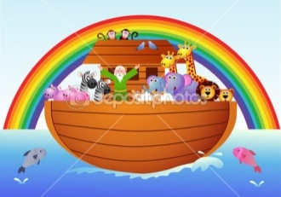
Additional Information
The mystery reader will begin next week, if you would like to come in and read to the children please mention it to one of our team and we can add you to our list. Parents evening will be happening on Monday 18th January and Tuesday 19th January. A separate letter will be sent out soon.
If you have any questions at all please do not hesitate to contact me.
Many thanks,
Mrs Yarwood and the EYFS team. cyarwood@scholargreen.cheshire.sch.uk

