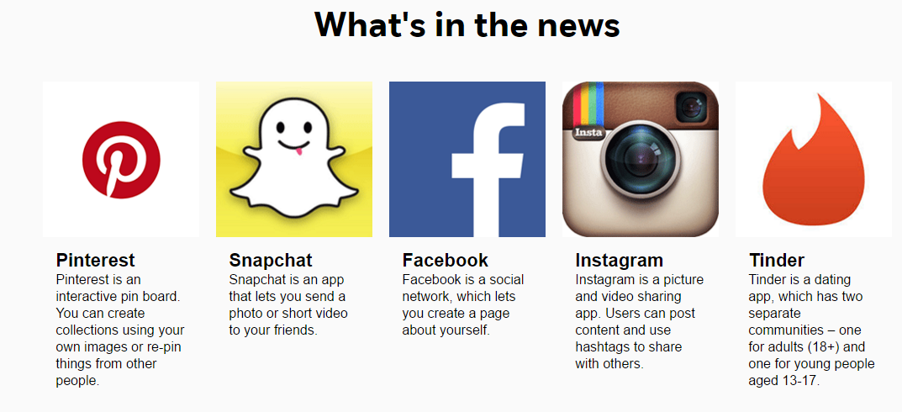

WWW.NET-AWARE.ORG.UK

Here is a useful link for parents to access a website that is a guide to social networks that children and young people use.

